**Experiment no. 7 : To Create Scrum Board for Scrum Master using JIRA Tool**

**SCRUM Board**

A Scrum Board is a visual tool in JIRA that helps Scrum Masters and teams manage sprints, track progress, and collaborate efficiently. It consists of different stages like To Do, In Progress, and Done, ensuring a clear workflow for Agile development.

Steps to Create a Scrum Board in JIRA

1. Create a New Scrum Project

1. Log in to JIRA and go to the JIRA Dashboard.
2. Click on “Create Project”.
3. Select Scrum Software Development and click “Next”.
4. Name your project and configure settings.
5. Click “Create” to set up the project.

2. Configure the Scrum Board

1. Navigate to Boards > Create Board.
2. Choose Scrum Board and link it to the project.
3. Define your workflow stages (To Do, In Progress, Done).
4. Customize columns, filters, and team settings.

3. Add User Stories & Tasks

1. Click Backlog and create Epics, User Stories, or Tasks.
2. Assign tasks to team members.
3. Set priorities, estimates, and due dates.

4. Start a Sprint

1. Click Backlog and create a new sprint.
2. Drag user stories into the sprint.
3. Click “Start Sprint”, set the sprint duration, and begin work.

5. Track Progress & Reports

* Daily Stand-ups: Use the Scrum Board to track daily progress.
* Burndown Charts: Monitor sprint completion rates.
* Sprint Reviews & Retrospectives: Analyze performance and improve future sprints.

Benefits of Using JIRA for Scrum Masters

* Enhanced Visibility → Provides a clear view of sprint progress.
* Efficient Collaboration → Teams can easily assign tasks and track work.
* Automation & Reporting → Built-in reporting tools help analyze sprint performance.
* Scalability → Suitable for small and large teams following Agile principles.

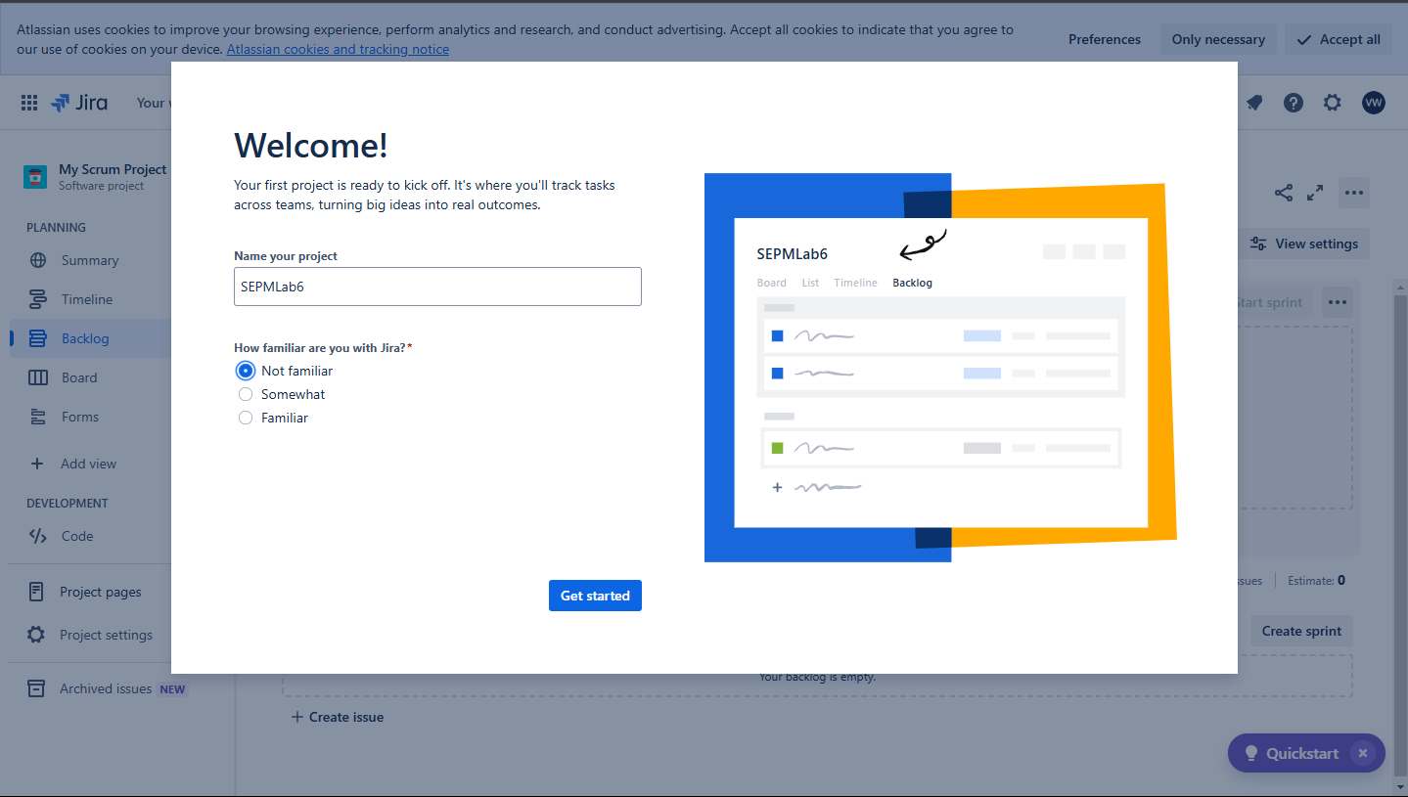

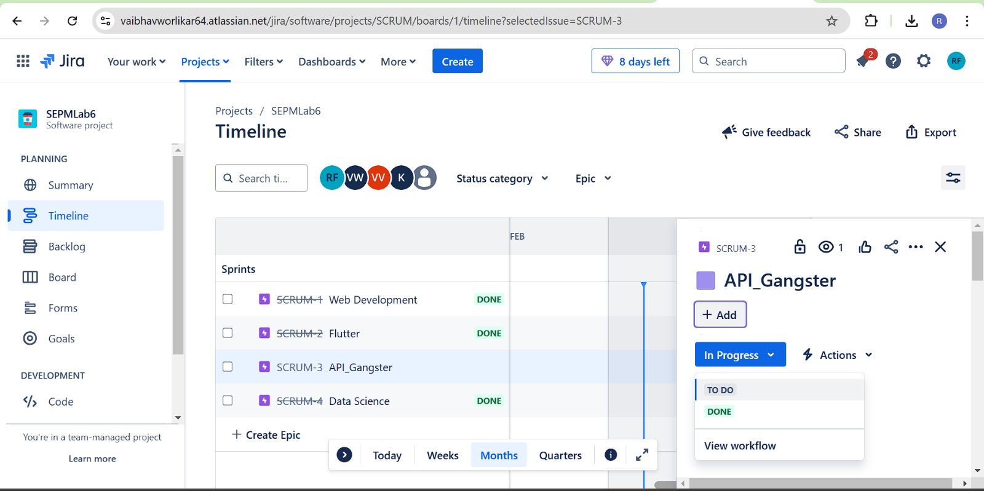

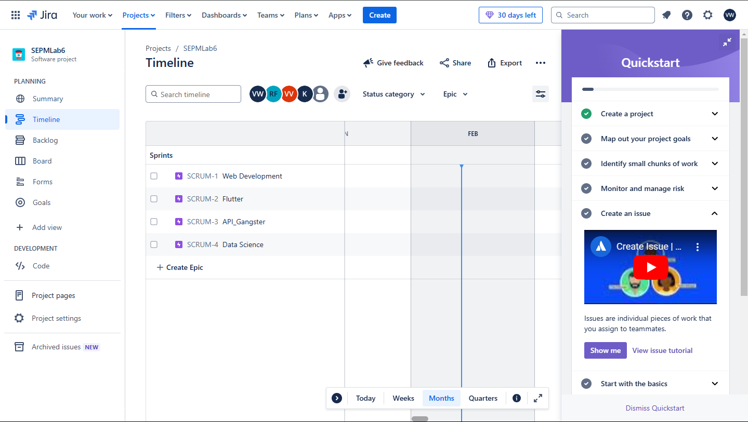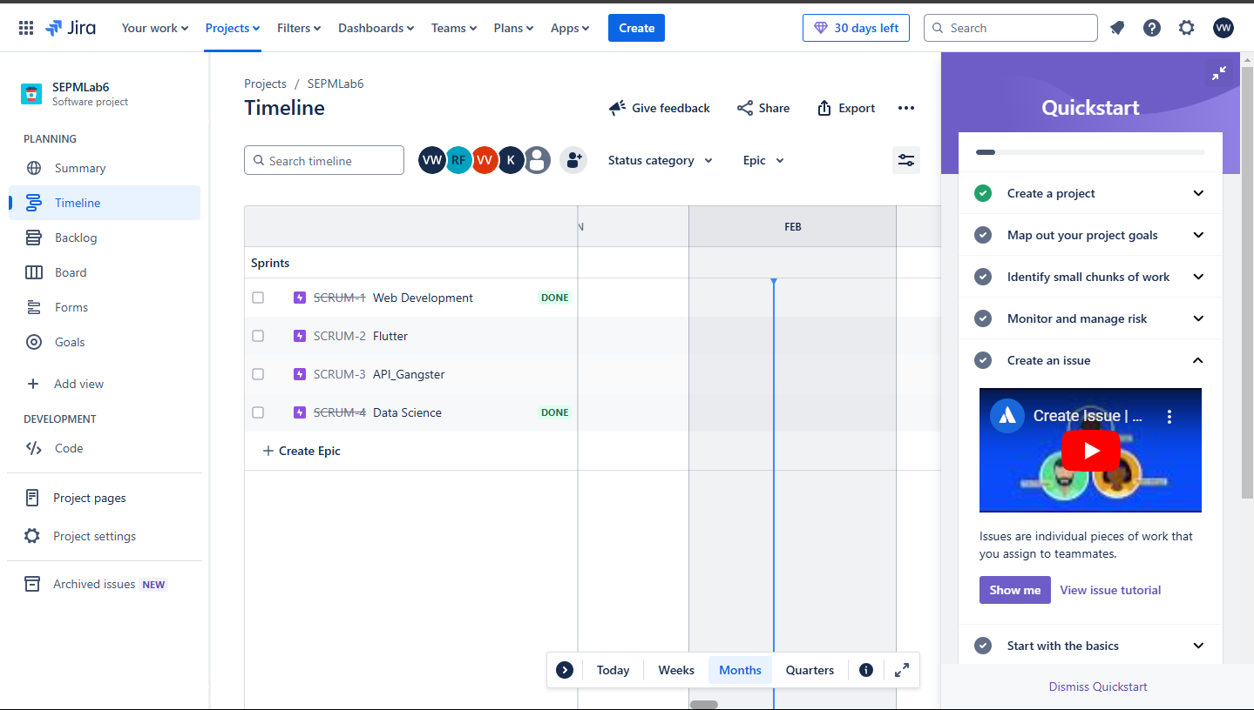

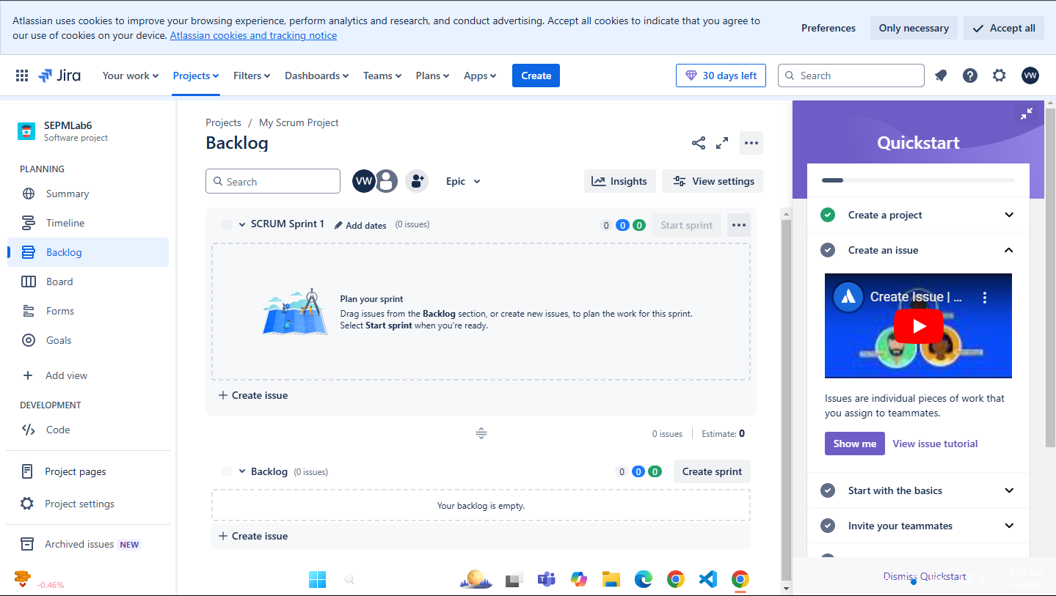

**Conclusion :** Thus we have successfully created scrum board for scrum master using jira tool